An Introduction to Deaf History in America
Excerpts from Deaf Heritage & Gallaudet University

Early Attempts to Educate Deaf Children
Almost 200 years after the Pilgrims arrived in this country there were still no schools for deaf children. It was believed that approximately 500 deaf people lived in the United States. A reverend named John Stanford met several deaf children in the New York City almshouse where he preached. He was concerned because they could not receive religious training, and although he had no experience with deaf persons, he set about try to teach them.

Founding Fathers of Deaf Education in America
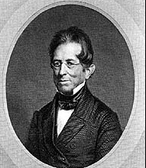
Around 1814, Thomas Gallaudet, a preacher, met Alice Cogswell, a 9 year old deaf girl and his neighbor. Dr. Mason Cogswell, Alice’s father and a prominent Hartford Physician, was concerned about proper education for his daughter. As his neighbor and friend, Gallaudet became equally concerned for this cause. He asked Gallaudet to travel to Europe to study methods for teaching deaf students, especially those of the Braidwood family in England. The two men gathered support from their friends, wealthy members of their community, and the city fathers and sent Gallaudet across the Atlantic Ocean to England. Upon arrival, Gallaudet found the Braidwood’s unwilling to share knowledge of their oral communication method. At the same time, he was not satisfied that the oral method produced desirable results.
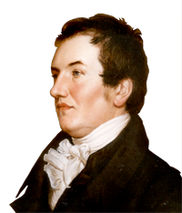
While still in Great Britain, he met the Abbe Sicard, head of the Institut Royal des Sourds-Muets, the first public school for the deaf in the world. Sicard invited Gallaudet to Paris to study the school's method of teaching deaf students using manual communication. Impressed with the manual method, Gallaudet studied teaching methodology under Sicard, learning sign language from Laurent Clerc, Sicard’s chief assistant and highly educated graduate of the school. Laurent Clerc was not born deaf, when he was about a year old, Clerc fell from his high chair into the kitchen fireplace. His right cheek was severely burned, a fever developed, and later, it was discovered that his senses of hearing and smell were damaged. It was never clear if this resulted from his accident or if he was born with those disabilities. His parents tried many different treatments to restore his hearing, but none succeeded. When he was twelve years old, his uncle-godfather enrolled him in the Institut National des Jeune Sourds-Muets, where he excelled in his academic studies.

Returning to America
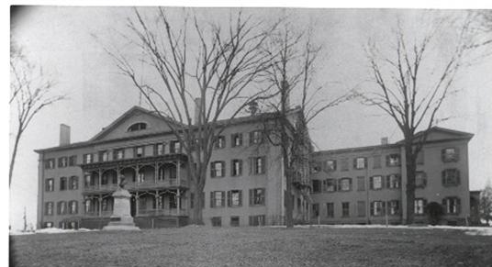
In 1816 Gallaudet convinced Laurent Clerc to return to America with him and establish a school for deaf children in America. The two men toured New England and successfully raised private and public funds to found a school for deaf students. The Connecticut Asylum for the Education and Instruction of Deaf and Dumb Persons in Hartford was founded in 1817. Laurent Clerc became America’s first deaf teacher of the deaf. There were seven pupils in the first class, Alice Cogswell being the first to enroll. The schools name would later be changed to the American School for the Deaf.
Clerc's mode of instruction was French signs. His students learned those signs for their studies. However, for their own use, they also borrowed or altered some of those signs and blended them with their own native sign language. As the Hartford students and teachers widely spread, Clerc's teachings in his original and in their modified signs, deaf communication acquired an identifiable form - evolving into the American Sign Language. Consequently, about two-thirds of today's ASL signs have French origins.
Within a year of the Connecticut Asylum opening its doors, New York City would establish the New York Institution for the Instruction of the Deaf and Dumb. Two years later Pennsylvania would open up an institution. But it wasn’t until 1823 that the first state-supported public school for the deaf – also the first one west of the Appalachian Mountains – opened in Danville, Kentucky.

Causes of Deafness
As schools were filling up, the administrators kept careful record of the causes of deafness of children entering their schools. Since information came from parents or guardians rather than from medical sources, some inventiveness will be noted.
Spinal meningitis was a leading cause of deafness. The Illinois School for the Deaf reported meningitis as the cause of deafness in 333 of its students who had enrolled during the first fifty years of the school’s existence. At the New York School for the Deaf 492 cases of deafness were attributed to scarlet fever. Other reports listed black tongue, sore eyes, summer complaint, nervous fever, sore mouth, fall into water, cramps, seasickness, cold water, sprain, clap of thunder, water on brain, lye, cold, fall on stove and salt in the ear. Six cases of “sickness of fright” were listed. In Arkansas, eating a buckeye was listed as the cause of one child’s deafness, and another case was blamed on the “mother’s conduct.”
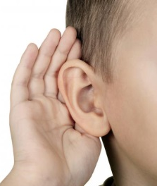
A swallow of tobacco “caused” one case, and a mother in New York claimed that during her pregnancy a servant’s piercing shriek made her baby’s ears close up. Teething and “impure blood” were listed among the causes at a Colorado school. Kentucky added the following: worms, morphine, sore head, lightning, fits, lung fever, cruelty, swimming, white swelling and sand in ears. James Beauchamp, who has been associated with Kentucky School as a student, teacher, editor, and board member, recalls the following story about the last cause: Two siblings overheard their parents talking about their younger brother. “Every time I tell him something, it goes in one ear, and out the other.” Puzzled, the two children took the little boy down to the creek, where they poured fine sand in one ear and then the other to see if it were true that what went in one and came out the other.

Deaf Teachers
Many students of the first deaf schools became teachers. This became a promising career for the deaf. In 1850, 36.6 percent of the teaching force in schools for the deaf in this country – excluding private and denominational schools - were deaf teachers. Eight years later, it peaked at 40.8 percent. Within the next decade, the percent fell because of the introduction of the pure oral method. Today the percentage of deaf teachers in schools and programs for the deaf is estimated at 13.6 percent.

Questions:
- How many deaf people were estimated to be in the United States in early 1800s?

- Where was the first public school for the Deaf located?

- What was the original name for the school for the deaf opened in Hartford, Connecticut in 1817?

- Who started this school? (2)

- Who was the first deaf teacher in America?

- What language does American Sign Language’s origin derive from?

- Where was the first public for the deaf established in the United States?

- What was the leading cause of deafness in the early deaf schools?

What were some strange causes of deafness? List at least 6.
- 12.
- 13.
- 14.
- What was the highest percent of deaf teachers in the teaching force?

- Why did the amount of deaf teachers take a steep decline the following decade?

