ASL Up-Close # 12
Numbers 11 - 20
11-15 - flick or wave backwards
- Palm ALWAYS faces in
- 13-15 –keep your fingers together
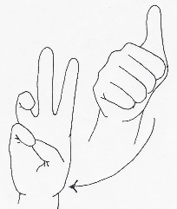
  - *3 Ways
- 10 + #
  - 10+6= 16, 10+7 = 17, 10+8 = 18, 10+9 = 19

- Twist the wrist
  - You simply hold the base # (for example 6), and twist your wrist outward to make the higher # (twist #6 = 16)

- Rub the thumb with the appropriate finger
  - For example, for 16 – make the 6 handshape then rub the pinky against the thumb.
Remember your hand should face out at the completion of the #.
You need to be familiar with them all!

<lifeprint.com>

