Deaf Culture Note # 13

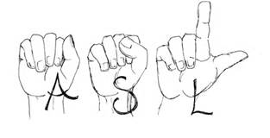
Is Sign Language Universal?
Sign language is not a universal language -- each country has its own sign language, and regions have dialects, much like the many languages spoken all over the world. Like any spoken language, ASL is a language with its own unique rules of grammar and syntax. ASL is used predominantly in the United States and in many parts of Canada. Like all languages, ASL is a living language that grows and changes over time.

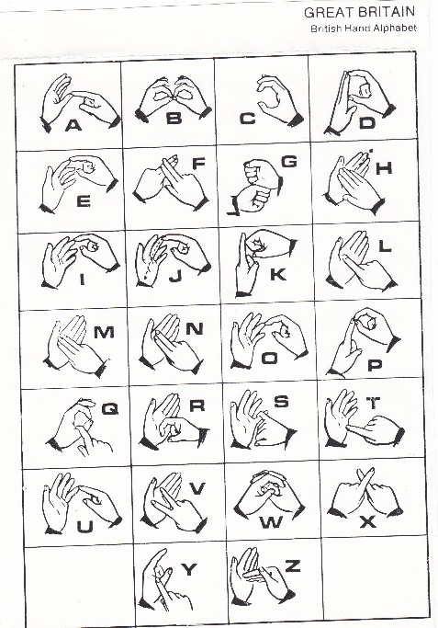
This is based on the misconception that sign language is basically the same as the gestures that we all make when needing to communicate wordlessly - nodding for 'yes', shaking our head for 'no', pointing at our chest for 'I', making the motion of raising a fork to the mouth for 'eating', putting a hand to the ear for 'hearing' and so on. It seems everybody knows/understands these without any training and it would follow that sign language builds on these. What people don't realize is that these gestures are far less universal than assumed (ex. the Chinese point at their nose for 'I', Hungarians nod their head for 'no' and shake their head for 'yes', ...)
Often people think because ASL is used in the United States that it must be similar to British Sign Language. One major different between ASL and BSL is that in ASL, we sign the alphabet with one hand, BSL uses a two-handed alphabet. Other sign languages use handshapes that aren’t recognized in ASL.
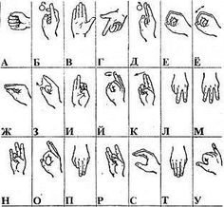
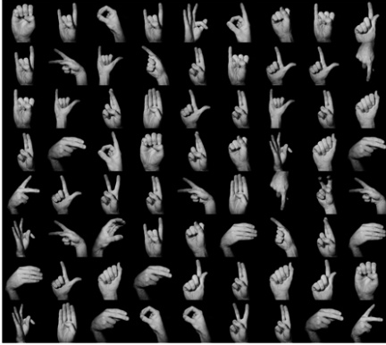
British Sign Language Alphabet
Russian Sign Language Alphabet

French Sign Language Handshapes

